Analysis of iQOO Neo 6 as an IoT Edge Device
Introduction
The iQOO Neo 6 is a powerful mid-range smartphone that can effectively function as an IoT edge device.
An IoT edge device collects data from its surroundings, processes it locally, and communicates with cloud systems or other devices. With high-performance hardware, advanced connectivity, and multiple sensors, this device is well-suited for IoT applications such as smart homes, health monitoring, automation, and real-time analytics.

1. Hardware Components of iQOO Neo 6
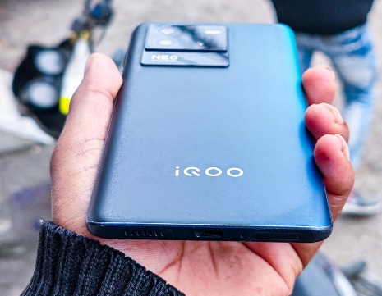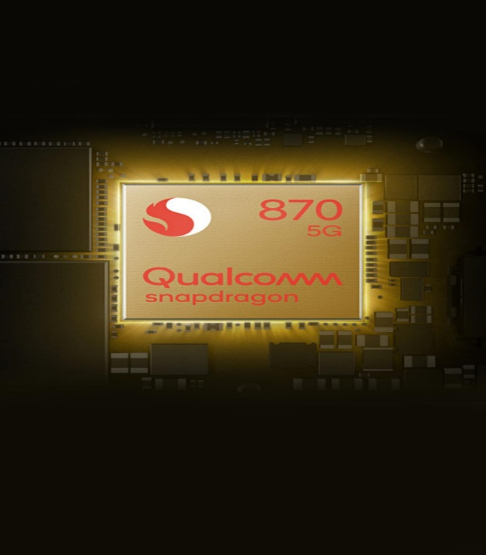

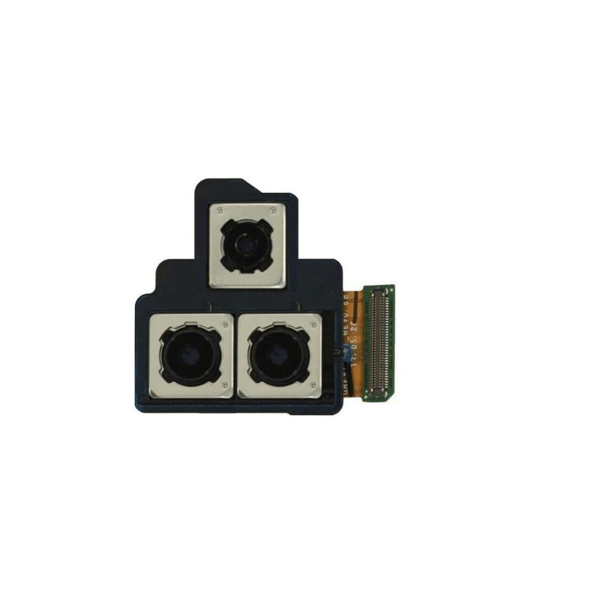
4
The hardware of the device plays a critical role in enabling edge computing capabilities.

Key Hardware Features
• Processor (CPU) and GPU
- Qualcomm Snapdragon 870 Octa-core processor
- Adreno 650 GPU
- Provides high-speed processing and AI-based computations
• Memory
- 8GB / 12GB RAM
- 128GB / 256GB Storage
- Supports efficient multitasking and handling of IoT workloads
• Battery
- 4700mAh battery
- Supports fast charging
- Suitable for continuous IoT operations
• Display/Input
- 6.62-inch AMOLED display
- Touchscreen interface
- Enables user interaction and control of IoT systems
• Camera System
- 64MP Triple Rear Camera
- 16MP Front Camera
- Useful for image processing, surveillance, and AI-based IoT applications
• Connectivity
- Wi-Fi, Bluetooth 5.2
- 4G LTE (some variants support 5G depending on region)
- Enables real-time communication with IoT networks
These features make the device capable of fast local data processing, storage, and communication, which are essential for an edge device.

2. Operating System (OS)
• OS Details
- Android 12 (upgradable)
- Funtouch OS (custom UI)
• Role of OS in IoT Edge Device
- Resource Management
Controls CPU, RAM, and battery usage efficiently
- Application Execution
Runs IoT applications such as automation apps and monitoring systems
- Security Features
Includes encryption, permissions, and biometric authentication
- Network Management
Handles Wi-Fi, Bluetooth, and mobile connectivity
- Sensor Integration
Provides APIs to access real-time sensor data
- The OS ensures smooth coordination between hardware, sensors, and IoT applications.

3. Sensors in iQOO Neo 6
Sensors are essential for data collection in IoT systems.
Available Sensors & Functions
- Accelerometer
Detects motion → Used in fitness and activity tracking
- Gyroscope
Measures rotation → Useful in AR/VR and navigation
- Proximity Sensor
Detects nearby objects → Used during calls
- Ambient Light Sensor
Adjusts brightness → Saves power
- In-display Fingerprint Sensor
Provides secure authentication
- Magnetometer (Compass)
Helps in navigation
- GPS
Provides accurate location tracking
- Ir blaster
These sensors allow the device to interact with real-world environments, making it highly suitable for IoT use cases.

4. iQOO Neo 6 as an IoT Edge Device
The iQOO Neo 6 satisfies all major edge device requirements.
Functions of an IoT Edge Device
• Data Collection
- Uses sensors (motion, location, light)
- Captures real-world data
• Data Processing
- Snapdragon 870 processes data locally
- Reduces latency compared to cloud-only systems
• Communication
- Sends/receives data via Wi-Fi, Bluetooth, or mobile networks
• Decision Making
- Can trigger actions (e.g., smart lights, alerts, automation systems)
This makes the device ideal for:
- Smart home control
- Health & fitness monitoring
- Real-time analytics
- Edge AI applications

5. Conclusion
The iQOO Neo 6 is a highly capable IoT edge device due to:
- Hardware: Powerful processor and connectivity
- Operating System: Efficient resource and security management
- Sensors: Accurate real-world data collection
Final Insight
Compared to Realme Narzo 30 4G, the iQOO Neo 6 offers:
- Better processing power (Snapdragon 870 vs Helio G95)
- More RAM options
- Faster performance for AI and edge computing
Therefore, it is more efficient and future-ready for IoT edge applications.

